|  |  |  |
| --- | --- | --- |
| Deu_logo | **DOKUZ EYLUL UNIVERSITY**  **ENGINEERING FACULTY**  **DEPARTMENT OF COMPUTER ENGINEERING** | logo-en |

**CME1214 LOGIC DESIGN**

**PRELIMINARY REPORT**

**LAB 3**

**by**

**Mesut Selim Serbes**

**2017510100**

**Lecturers**

**Instructor Dr. Özlem Öztürk**

**Res.Asst. Dr. Feriştah Dalkılıç**

**Res.Asst. Özlem Yerlikaya**

**Res.Asst. Gökmen Katipoğlu**

**IZMIR**

**09.04.2019**

* + - 1. **TRUTH TABLE**

**1.Experiment**

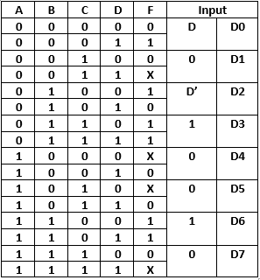

**2.Experiment**

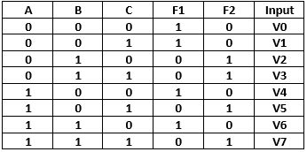

* + - 1. **KARNAUGH MAPS**

**1.Experiment**

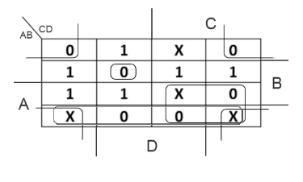

**F** = (B+D) \* (A’+B) \* (A’+C’) \* (A+B’+C+D’)

**2.Experiment**

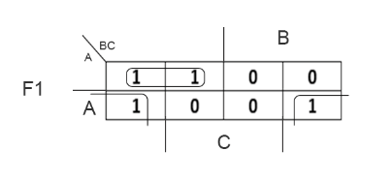

**F1** = (A’\*B’) + (A\*C’)

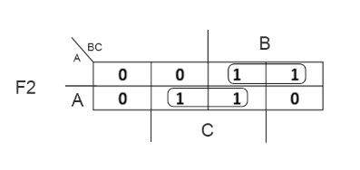

**F2** = (A’\*B) + (A\*C)

* + - 1. **LOGIC DIAGRAM**

**1.Experiment**

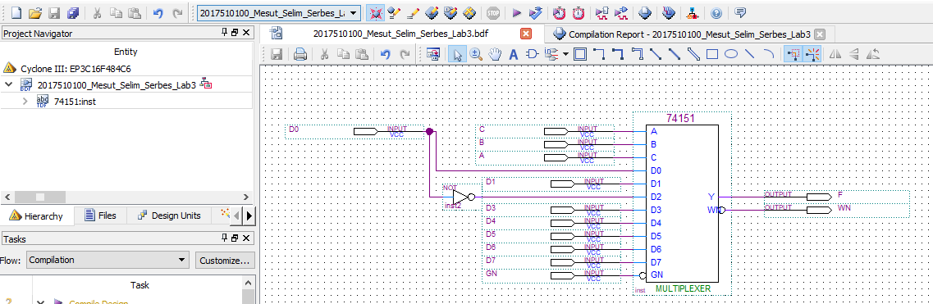

**2.Experiment**

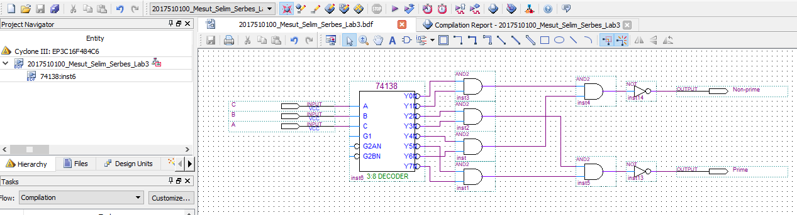

* + - 1. **WAVEFORMS**

**1.Experiment**

**Functional Waveform**

**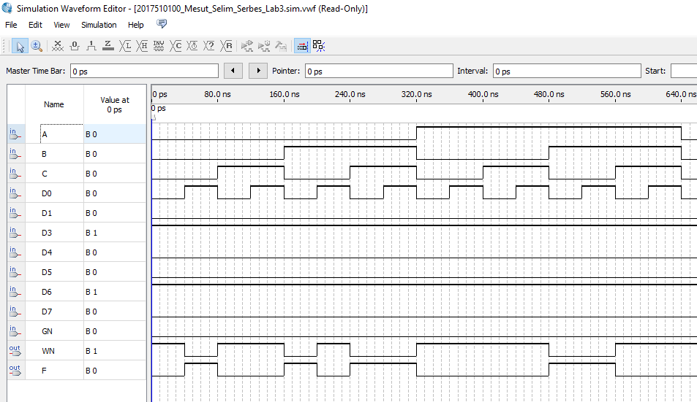**

**Timing Waveform**

**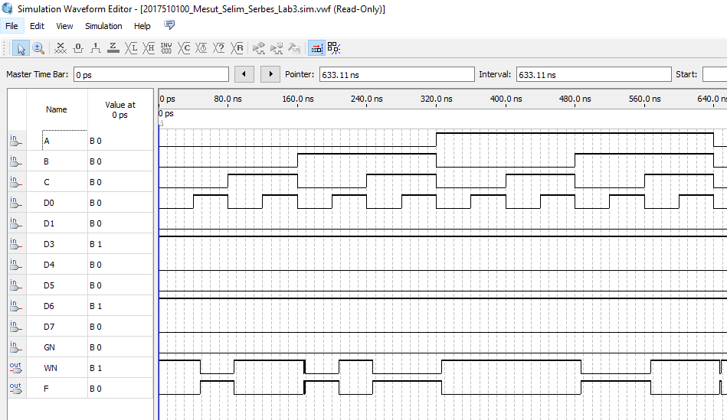**

**2.Experiment**

**Functional Waveform**

**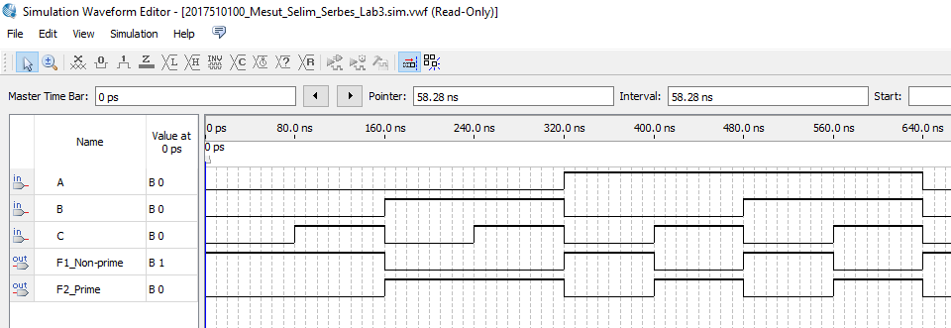**

**Timing Waveform**

